STA2023 – Statistical Methods I
Instructor: Dr. Emil Agbemade
Chapter 8. Confidence Intervals
Table of Contents
8.1 Estimating a Population Proportion 2
Types of Estimators 2
Constructing and Interpreting a Confidence Interval for the Population Proportion 3
General Formula for a Confidence Interval for the Proportion: 5
Sample Size Calculations: 8
8.1 Estimating a Population Proportion 2
Types of Estimato`rs 2
Constructing and Interpreting a Confidence Interval for the Population Proportion 3
General Formula for a Confidence Interval for the Proportion: 5
Sample Size Calculations: 8

Learning Objectives: By the end of the chapter, students should be able to:
- Explain what a confidence interval does.
- Construct and interpret confidence intervals for a proportion.
- Construct and interpret confidence intervals for a mean.
- Perform sample size calculations to determine the minimum sample size needed to a specified margin of error.

8.1 Estimating a Population Proportion

Types of Estimators
- Often times, the population parameter, such as p or µ, are unknown in the population.
- To estimate these values, we can draw a random sample, then use information from that sample (a sample statistic) to estimate something from the population (a population parameter)
- Generally, we have two types of estimators:
  - A point estimate is

  - An interval estimate is

- Interval estimators are typically preferred over point estimates since we don’t expect to get the same statistic from sample to sample. The interval estimate allows us to quantify the uncertainty we get from random sampling.
- For this section, we will focus on the population proportion. If we want to estimate p, the population proportion, then we need a point estimate using a statistic.
- Definition: The point estimate for the population proportion is

Example 1: The Gallup Organization conducted a poll in which a simple random sample of 1015 Americans 18 and older were asked, “Do you consider the amount of federal income tax you have to pay is too high?” Of the 1015 adult Americans surveyed, 458 said yes. Obtain a point estimate for the proportion of Americans 18 and older who believe the amount of federal income tax they pay is too high.

Constructing and Interpreting a Confidence Interval for the Population Proportion
- In the last example, could we conclude less than a majority (less than 50%) of the US adult population believe that the amount of federal income tax they pay is too high?
  - In other words, is it possible that more than 50% actually do believe they pay too much, but we just happened to get a sample where less than 50% did?
  - The sample proportion, $\hat{p}$, varies from sample to sample. We got 45.1% on the first sample, but if we took another sample, we may get 55%.
- We want to quantify the fact that sampling with not be the same every time, so we want to report a range (or interval) of values that has a high likelihood of including the population proportion.
Definition: A confidence interval for an unknown parameter consists

Definition: The level of confidence represents

- How do we construct such an interval?
- We know the sampling distribution of $\hat{p}$, the sample proportion.

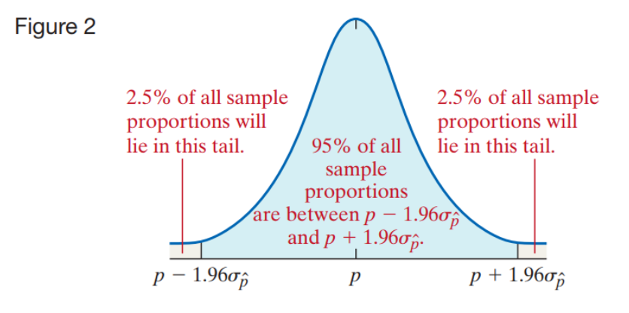

- Notation for a (1-α)*100% confidence interval:

General Formula for a Confidence Interval for the Proportion:
For any (1-α)*100% confidence interval:
(point estimate) ± (Margin of error)

Margin of error = Critical value * Standard Error

For the proportion:
- Critical Value
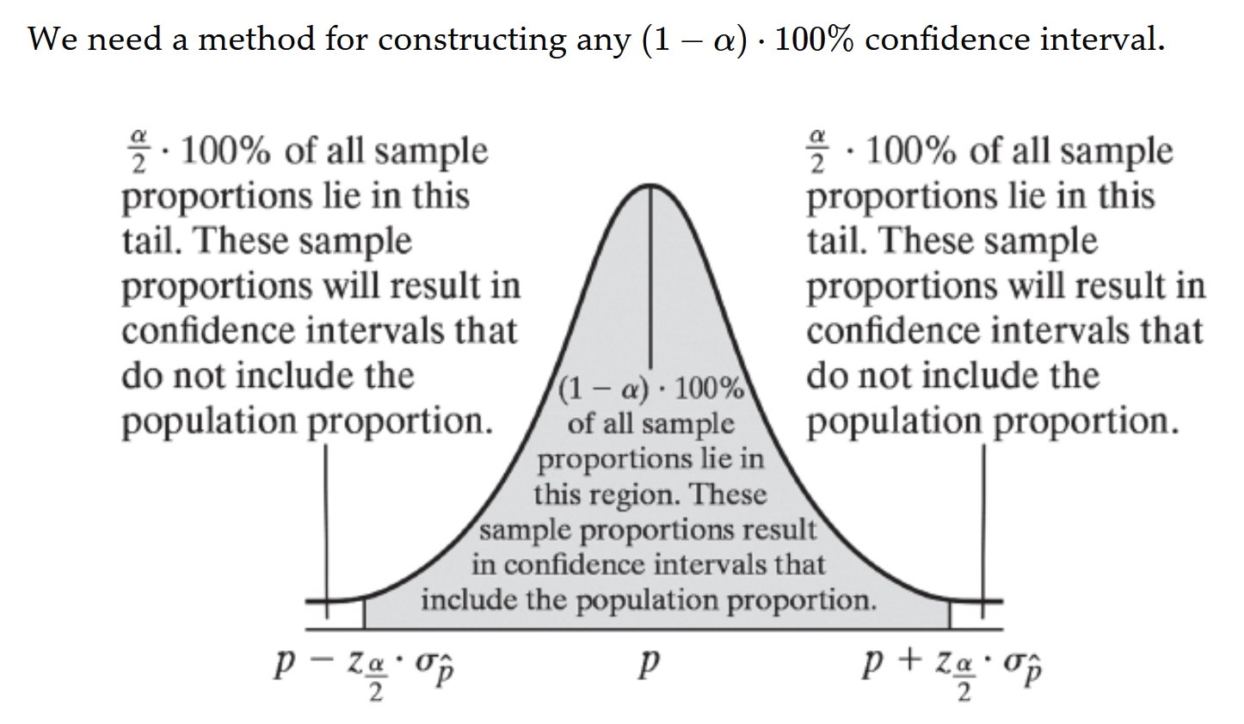
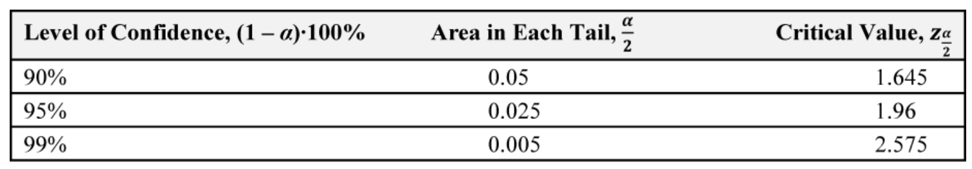

Suppose that a simple random size of size n is taken from a population or the data is the result of a randomized experiment. A (1-α)*100% confidence interval for p is given by the following quantities:

Example 2: When the Gallup Organization conducted the poll introduced in Example 1, 45.1% of those surveyed considered the amount of federal income tax they have to pay as too high. Gallup reported its “survey methodology” as follows:

Results are based on telephone interviews with a random sample of 1015 national adults, aged 18 and older. For results based on the total sample of national adults, one can say with 95% confidence that the maximum margin of sampling error is 4 percentage points.

Determine and interpret the confidence interval for the proportion of Americans aged 18 and older who believe the amount of federal income tax they have to pay is too high.

General Approach to Construction Confident Intervals for a proportion:
- Step 1: Compute the sample proportion.
- Step 2: Verify the data was obtained through a random sample. Verify that $n\hat{p}\left(1-\hat{p}\right)≥10$ (normality condition) and n ≤ 0.05N (sample size is nor more than 5% of the population size – independence condition)
- Step 3: Determine the critical value $z_{α/2}$.


- Step 4: Use the following formula:
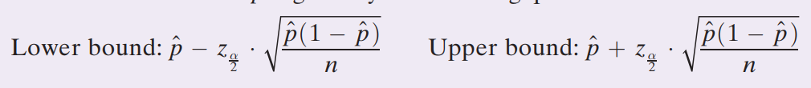
- Step 5: Interpret the result in context of the question.

Example 3: In the Parent–Teen Cell Phone Survey conducted by Princeton Survey Research Associates International, 800 randomly sampled 16- to 17-year-olds living in the United States were asked whether they have ever used their cell phone to text while driving. Of the 800 teenagers surveyed, 272 indicated that they text while driving. Obtain a 95% confidence interval for the proportion of 16- to 17-year-olds who text while driving.

Example 4: Repeat the same problem above, but with a 99% confidence interval.

Sample Size Calculations:
- We know that larger sample sizes produce more precise estimates. Given the margin of error is:
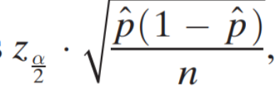
E =
We can see that n increases, the margin of error decreases. What happens if we want to prespecify a margin or error before a study? What sample size would we need for that?
- We can set the margin of error listed above equal to our desired margin of error. However, the standard error involves the sample proportion, but we are determining the sample size needed to get the sample proportion, so how to we deal with that?
- Two methods:
  - We have previous knowledge of the proportion
  - We assume the proportion with the largest amount of variation to get a conservative estimate.
- Solving the equation above for n:

Example 5: An economist wants to know if the proportion of the U.S. population who commutes to work via carpooling is decreasing. What size sample should be obtained if the economist wants an estimate within 2 percentage points of the true proportion with 90% confidence if
(a) the economist uses the 2009 estimate of 10% obtained from the American
Community Survey?
(b) the economist does not use any prior estimates?

8.2 Estimating a Population Mean
- What happens if we want to construct a confidence interval for a population mean?
- Confidence intervals, no matter what the parameter is, work the same way:
  - Point estimate ± margin of error
- What is the point estimate of the population mean?

- What is the margin of error? Remember that the distribution of the sample mean is normally distributed if the sample size is large.

- Putting this all together, we get the following formula:

- However, there’s an issue. If we don’t know the population mean, we surely don’t know the population standard deviation σ. How do we adjust for this?
  - We can use the sample standard deviation s instead of σ. However, this does not make the sample mean normally distributed. Instead, we have to use a different distribution: Student’s t-distribution (often just referred to as the t-distribution).
  - Since the sample standard deviation is not great at estimating the population standard deviation, we need to adjust for that fact.

T-Distribution
Definition: Suppose a simple random sample of size n is taken from a population that follows a normal distribution.

Properties:
- The t-distribution is different for different degrees of freedom.
- The t-distribution is centered at 0- and is symmetric about 0.
- Area under the curve is 1. Area to the left of 0 and the right of 0 and equal (1/2)
- As t increases or decreases without bound, the graph approaches (but never equals) 0.
- The area in the tails of the t-distribution is a little greater than the area of a standard normal distribution. This is because we are using s as an estimate of σ, thereby introducing further variability into the t-statistic.
- As the sample size n increases, the density curve of t gets closer to the standard normal density curve.

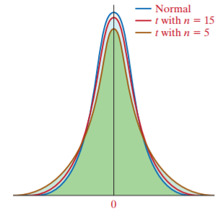
Adjusted confidence interval formula:

How do we find that critical t-value?
- We use t_{α} notation to indicate the t-value whose area under the t-distribution to the right of this point is α. Shown visually:

- We can follow the method on the below table:
Table:
Step 1: Draw the t-distribution with the unknown t-value labeled. Shade the area under the curve to the right of the t-value.
Step 2: Find the row in Table VII (at the following pages of this packet or Webcourse Module 8) corresponding to the n-1 degrees of freedom and the column corresponding to the area in the right tail of α.

Example 6: Find the t-value such that the area under the t-distribution to the right of the t-value is 0.10, assuming 15 degrees of freedom (df).

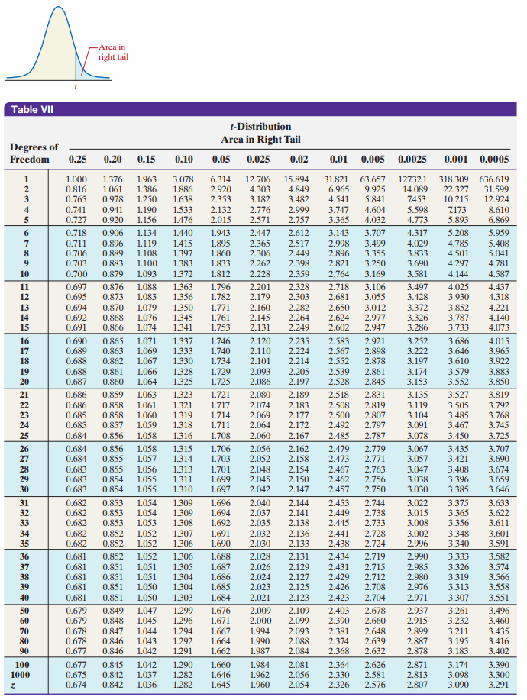
Example 7: Find the t-value such that the area under the t-distribution to the right of the t-value is 0.05, assuming 10 degrees of freedom (df).

Constructing Confidence Intervals for the Mean
Constructing a (1-α)*100% Confidence Interval for μ:
- Provided:
  - Sample data come from a simple random sample or randomized experiment,
  - Sample size is small relative to the population size (n ≤ 0.05N), and
  - The data come from a population that is normally distributed, or the sample size is large.
- Then, a (1-α)*100% Confidence Interval for μ is given by:

Example 8: The website fueleconomy.gov allows drivers to report the miles per gallon of their vehicle. The data in Table 3 show the reported miles per gallon of 2019 Honda Accord Hybrid automobiles for 16 different owners. Treat the sample as a simple random sample of all 2019 Honda Accord Hybrid automobiles. Construct a 95% confidence interval for the mean miles per gallon of a 2019 Honda Accord Hybrid. Interpret the interval.
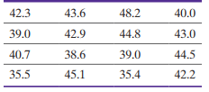 (Note: $\overline{x}=41.55, s=2.51$)

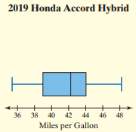

Example 9: In a class of 35 students, an instructor wants to know if their class meets the requirements that the average score should be 80 points. After giving the test, the sample mean score was 77.8 points with a standard deviation of 7.3 points. Construct a 90% confidence interval for the average score. Is 80 a reasonable average score to assume?

- Note: what happens if the sample size is small and clearly skewed?
  - We would want to use a nonparametric method, which is covered in Statistical Methods II.

Calculating Sample Size
- What happens if we want a specific margin of error and need to figure out the sample size associated with that?
- We can use the margin of error to figure this out (note: we use a critical z since a critical t depends on the sample size, which we are solving for):

- Another note: we need the value of s to come from a pilot study or prior study. There are other methods of estimating them for sample size purposes, but it will always be provided in this class.

Example 10: We again consider the problem of estimating the miles per gallon of a 2019 Honda Accord Hybrid. How large a sample is required to estimate the mean miles per gallon within 0.5 mile per gallon with 95% confidence? Recall that s = 3.51.

